AWS ADVANCE PROJECT 6:
Project Name: Installing and Configuring Apache tomcat server on Linux
- Install java
To install Java, use command;
- sudo su to change to root user.
- Use command; yum install java-1.8*
Screenshot for java installation.
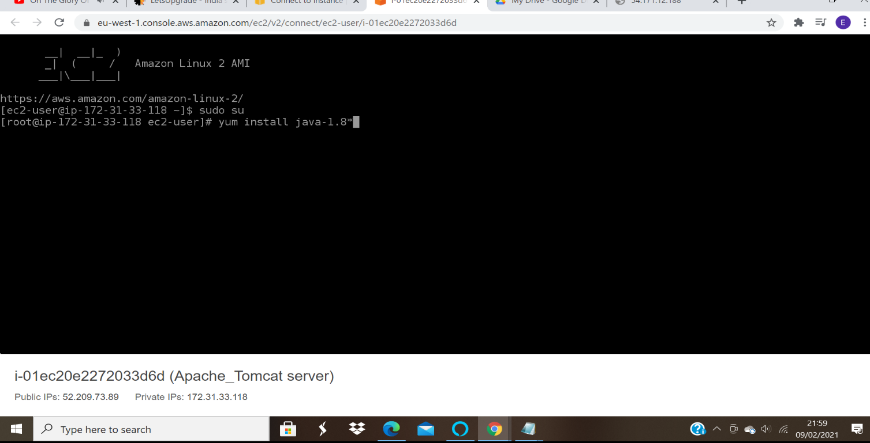

2. Install tomcat:
To install tomcat move, opt folders as below
- cd /opt
- wget https://mirrors.estointernet.in/apache/tomcat/tomcat-8/v8.5.61/bin/apache-tomcat-8.5.61.tar.gz
Screenshot of tomcat installation.
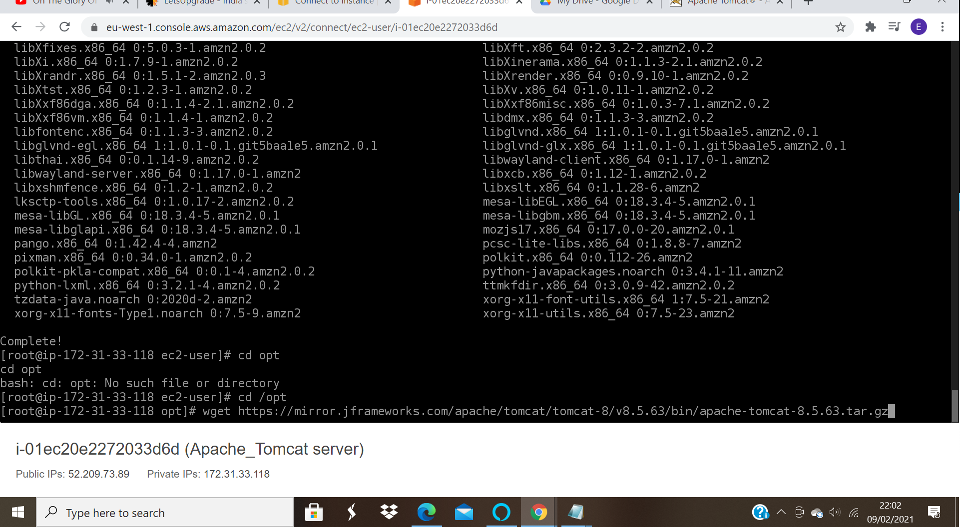
- tar -zvxf apache-tomcat-8.5.61.tar.gz
- tar-zvxf command is for extracting files form the folder.
Screenshots
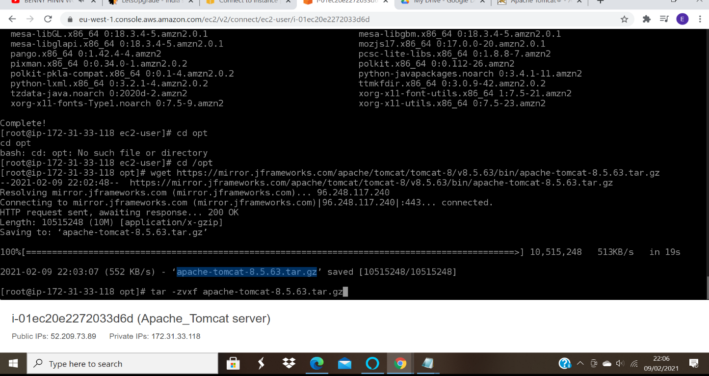

Modify permissions for startup.sh and shutdown.sh.
Before modifying, check on permissions allowed.
Ps -ef | grep filename command is used
- chmod +x startup.sh
- chmod +x shutdown.sh
Screenshots for modif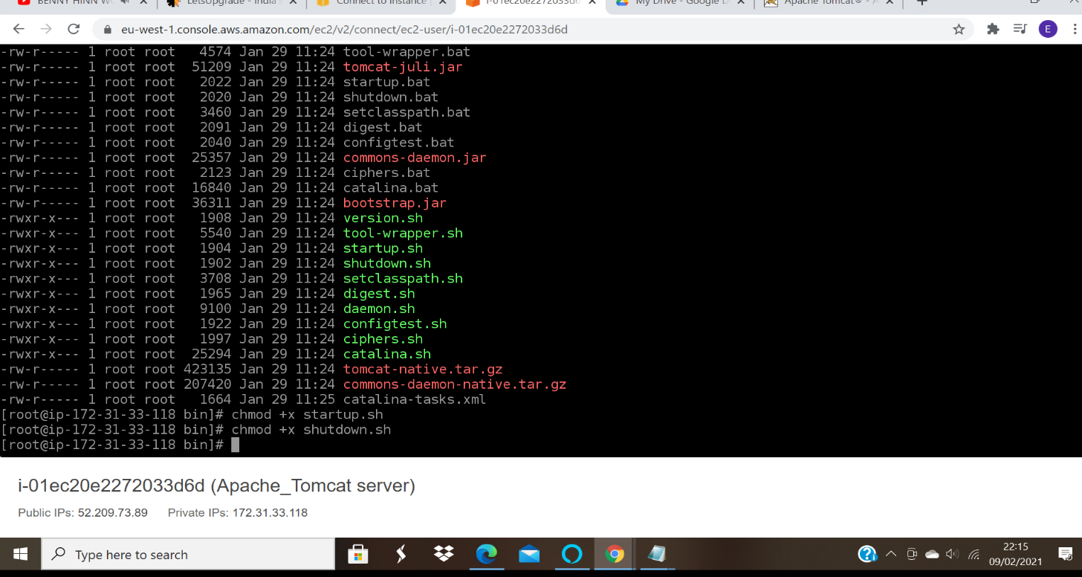ying permissions.
Create a softlink; to enable access to folders and execution of commands from any folder.
Use echo $PATH command to find the path and find / -name startup.sh

- ln -s path /usr/bin/tomcatup
- ln -s path /usr/bin/tomcatdown
Screenshots
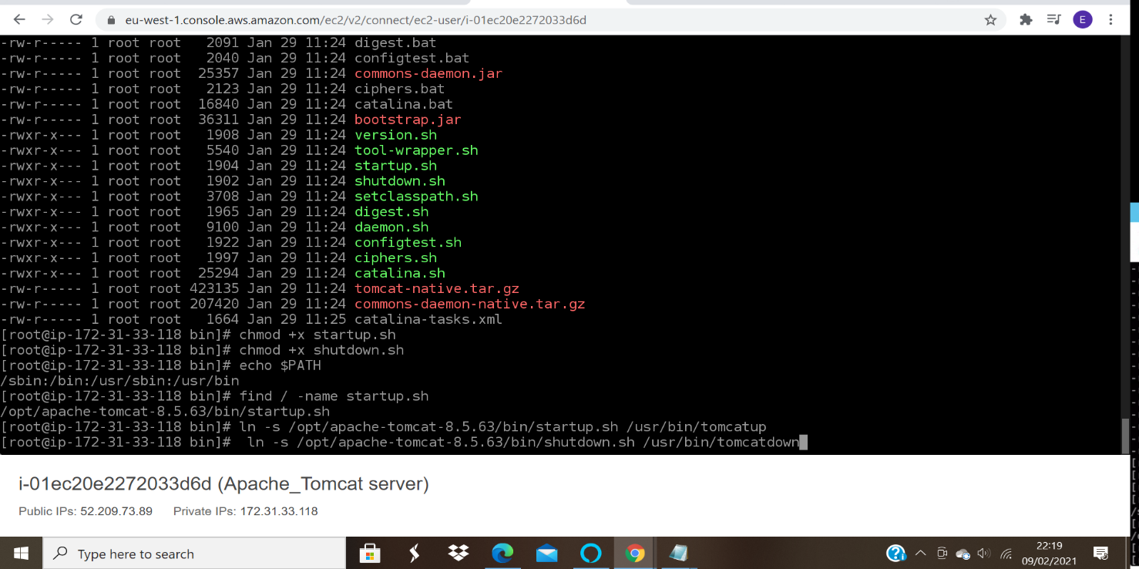

Screenshot of restarting the tomcat after creating soflink:
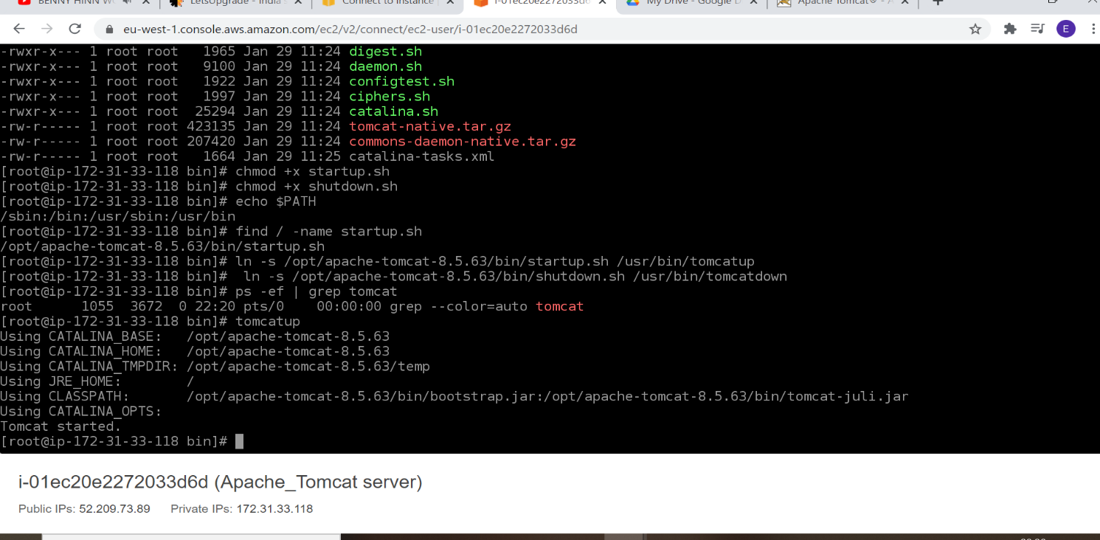
Screenshot of Apache tomcat page after creating softlink in port 8080
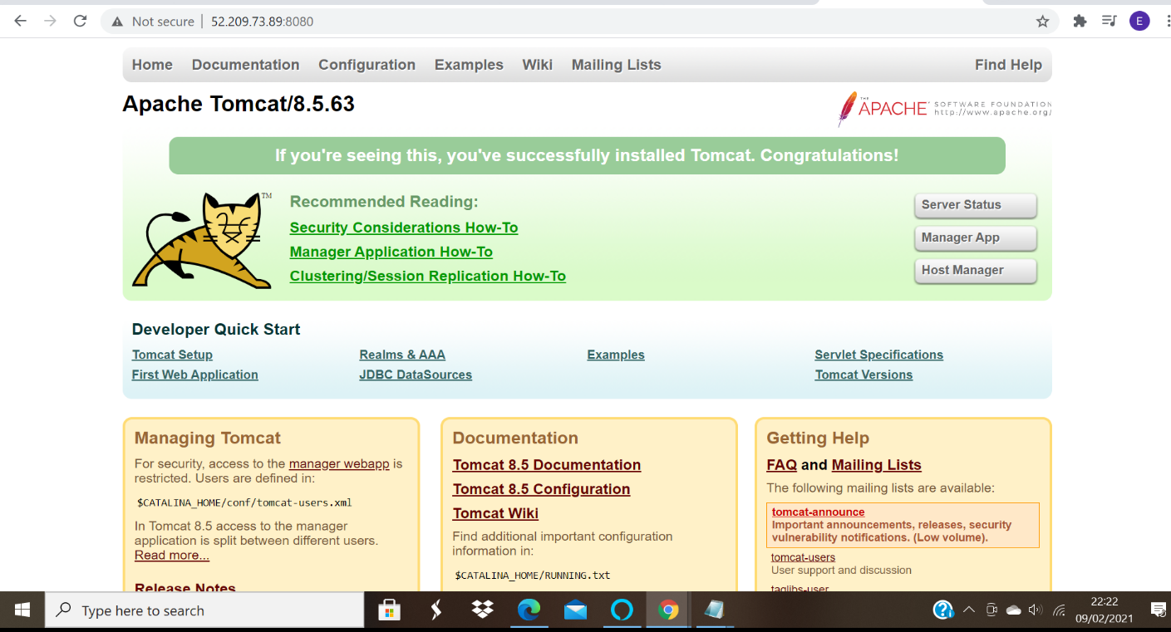
Change the port to 8090
- edit server.xml
- vi server.xml
Screen shot after editing server. xml by changing port from 8080 to 8090
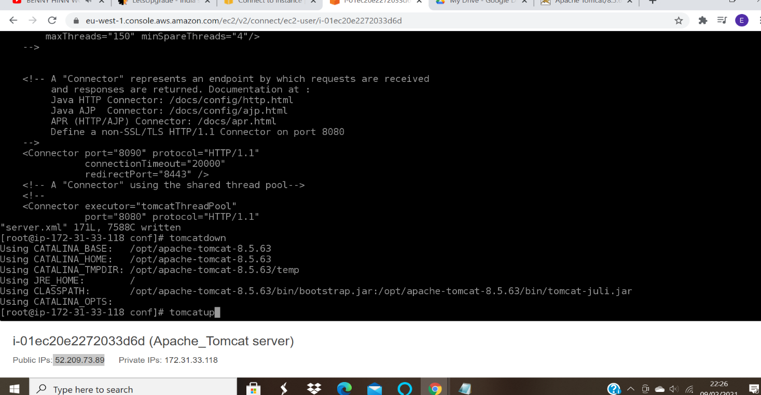
- check configuration in 8090

- 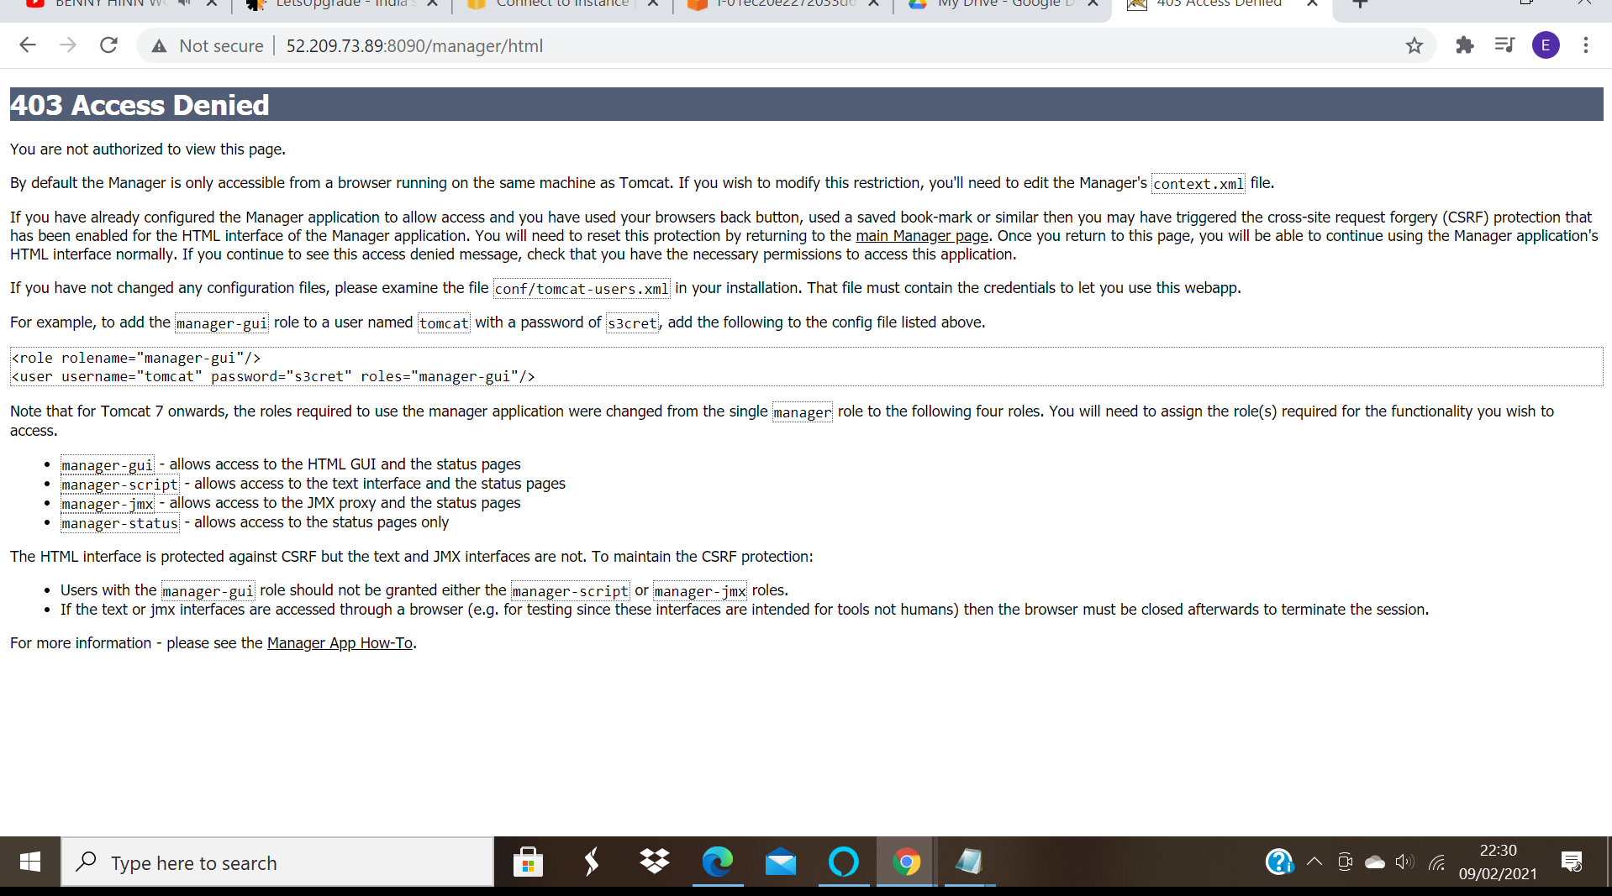

Edit context.xml to allow manager apps access
- vi context.xml
- comment Valve
Screenshot after commenting the Valve;
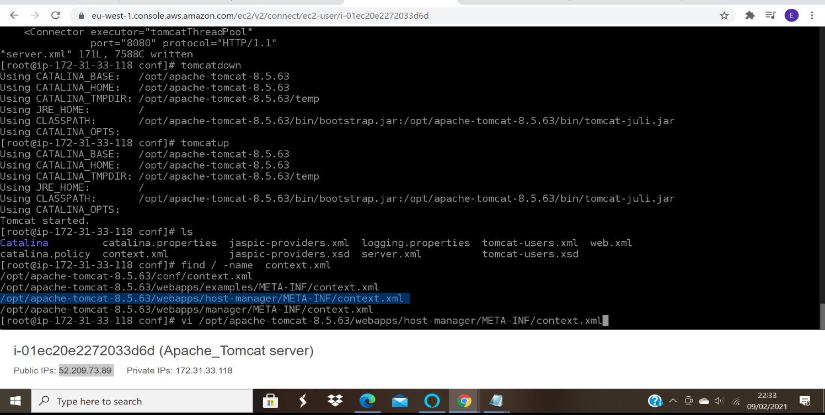
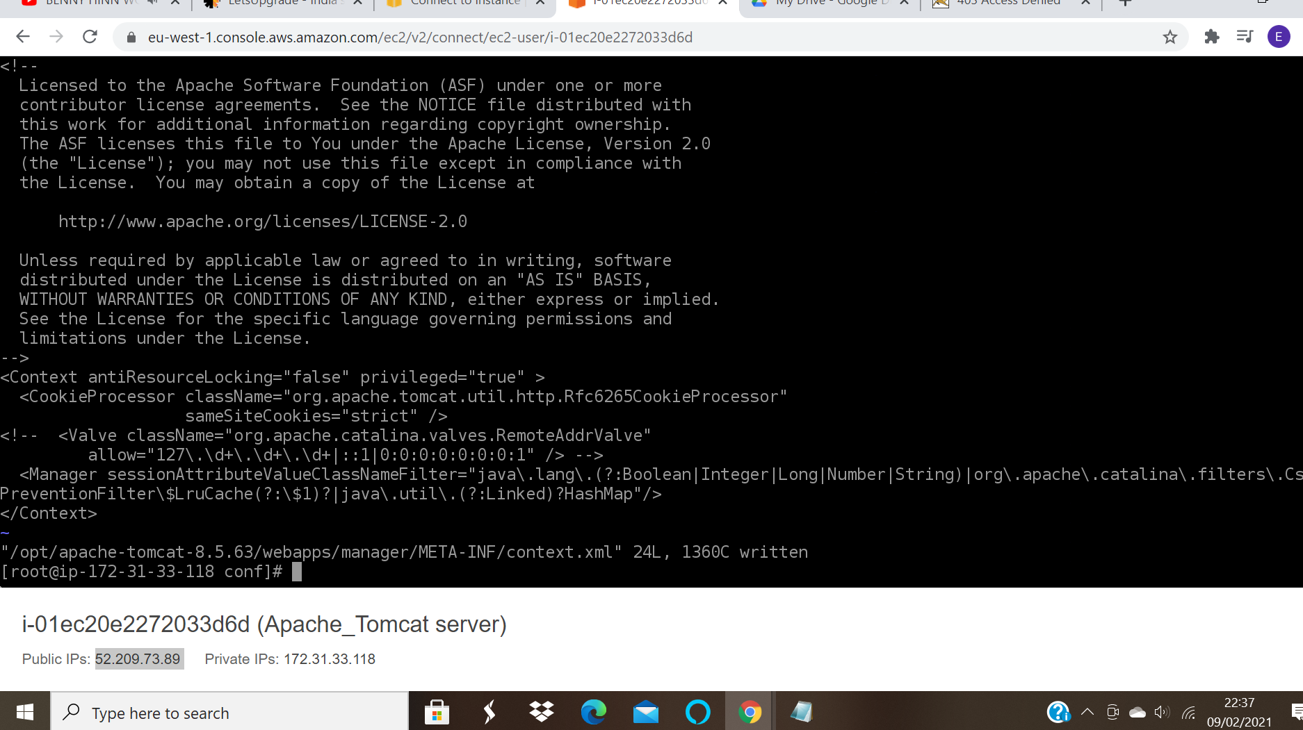

Screenshot of the manager html after editing context.xml
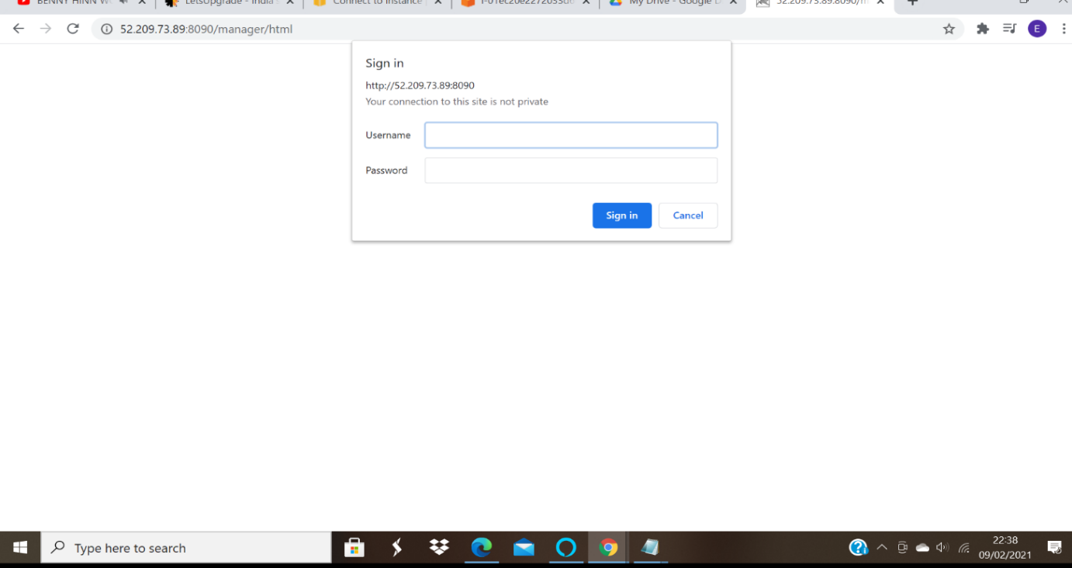

Add users and roles to tomcat-users.xml
- vi command is used for editing files.
- vi tomcat-users.xml
Screenshot of tomcat-users implementation:
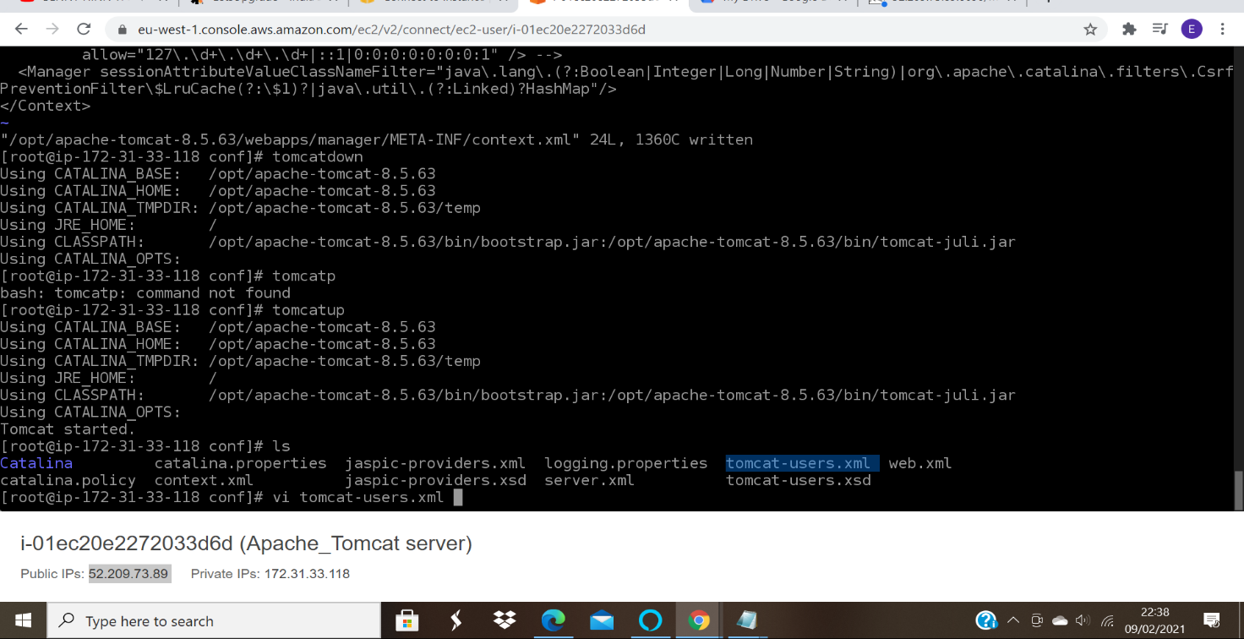

Add the following roles
- <role rolename="manager-gui"/>
- <role rolename="manager-script"/>
- <role rolename="manager-jmx"/>
- <role rolename="manager-status"/>
- <user username="admin" password="eve123"
roles="manager-gui,managescript,manager-jmx,manager-status"/>
- <user username="deployer" password="eve123" roles="manager-script"/>
- <user username="tomcat" password="eve123" roles="manager-gui"/>
Screenshot after editing the tomcat-users.xml:
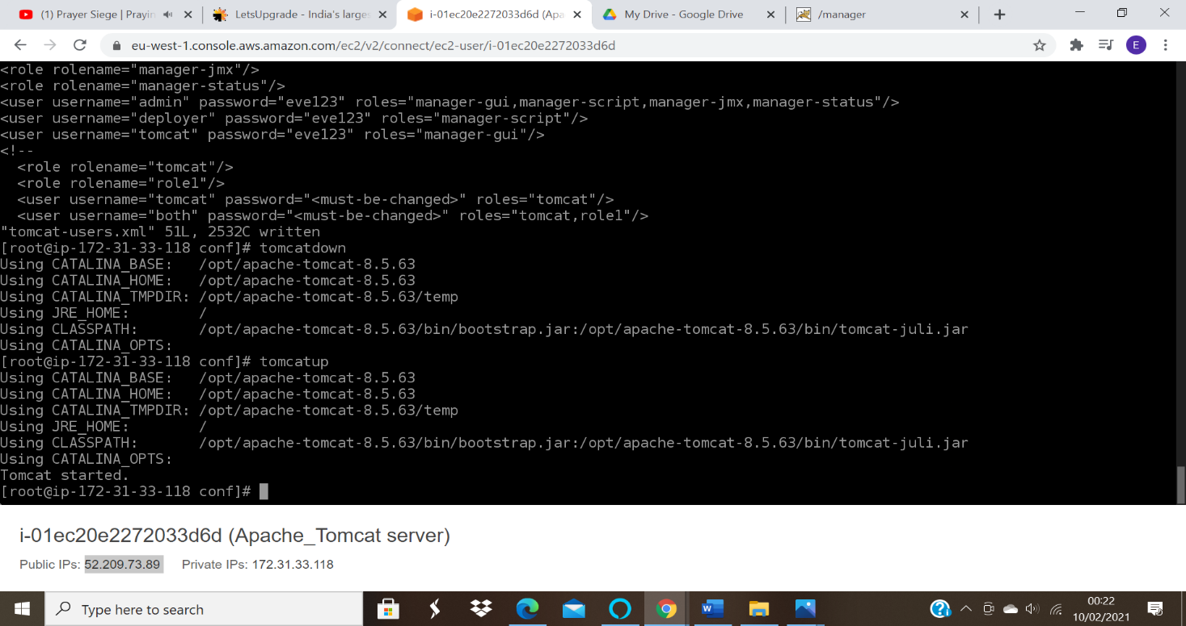
Give a restart and check for web application manager
Screenshot of refreshed page of tomcat web page manager:
